Application of Self-Improving Q-learning Controller for a Class of Dynamical Processes: Implementation Aspects

Jakub Musial¹, Krzysztof Stebel¹, Jacek Czeczot^{1*}, Pawel Nowak¹, Bogdan Gabrys²

¹Silesian University of Technology, Faculty of Automatic Control, Electronics and Computer Science
Department of Automatic Control and Robotics, Gliwice 44100, Poland.

²Complex Adaptive Systems Laboratory, The Data Science Institute, Faculty of Engineering and Information Technology, University of Technology Sydney, New South Wales 2007, Australia

*corresponding author: J. Czeczot (jacek.czeczot@polsl.pl)

ABSTRACT

This paper deals with a practical application of the Q-learning algorithm as a general-purpose self-improving controller operating in a class of industrial closed-loop control systems. The proposed approach solves a practical control engineering problem by designing a controller that starts its operation with the predefined closed-loop control performance and then, without unnecessarily disturbing the normally operated closed-loop system, it learns on-line from interactions with the controlled process to ensure the gradual improvement in the closed loop control performance until this performance reaches a desired user-defined level. It is proposed how to ensure its initial performance by an appropriate initialization of the Q-matrix without assuming any knowledge about the process model. The desired target closed-loop performance is defined by the first-order reference trajectory that should be preserved by the closed-loop system, which requires determining the current state of the closed-loop system by the values of the control error and its time derivative. The novelty of the proposed approach results from: (i) preserving the first order reference trajectory with reduced dimensions of the Q-matrix to two, which significantly reduces memory and computational requirements without any loss of generality, (ii) proposing a method for a reduction of the number of states designed directly for the proposed approach, and (iii) proposing a method for a very convenient initialization of the Q-matrix based only on the tunings of the existing PI controller. All these features bring the proposed approach closer towards practical applications. Results of the simulation and experimental validation show that the proposed Q-learning controller can substitute the existing PI controller bumplessly and provides a gradual improvement in the closed loop performance due to its online learning abilities.

KEYWORDS

Q-learning algorithm, reinforcement learning, process control, online learning, intelligent control, practical validation.

This work was supported in part by the grant from SUT - subsidy for maintaining and developing the research potential in 2023 and by BKM grant (02/060/BKM22/0037).

1. INTRODUCTION
The Q-learning algorithm has been widely investigated and applied to different applications by both researchers and practitioners. It was proposed as an effective model-free reinforcement learning (RL) method [1]-[2] and, currently, according to the Web of Science database, only around 750 scientific articles related to this topic have been published within 2019-2022. Among these articles, about 100 are related to the application of the Q-learning algorithm directly for the control of various processes, which shows the potential applicability of this methodology in the process automation as a single loop controller, when the quality of control is a very important issue. Practical reports show that the performance of over 60% of PID (proportional-integral-derivative)-based control loops is poor [3] and, in the vast majority of cases, it is due to inadequate tuning of the individual controllers [4]. Usually, retuning these controllers is a fast and low-cost remedy, but, in practice, it is not easy. Such poorly performing closed loops are difficult to locate because, in a single factory, dozens or even hundreds of control loops can operate simultaneously [5]. At the same time, even if they are located, their retuning requires expert knowledge and practical experience supported by experimental data. Thus, it would be very convenient to substitute an existing poorly operating controller with a self-improving controller that could start its closed-loop operating with an initial performance similar to the existing one and then, due to online learning, could gradually improve its performance until the desired closed-loop performance is reached. This feature should be obtained without assuming any knowledge of the model of the process dynamics, such as the order of the process dynamics, oscillatory behavior, approximated values of the process time constants, process gain, etc. Note that when the accurate (or only approximated) model of the process is known, there are many different model-based techniques that could be directly used to derive the controller that performs effectively without the necessity of any learning stage. At the same time, if accessible, the process model can be used for retuning of the existing PI controller to ensure a significant closed loop performance improvement. Thus, the proposed solution should be applicable without this knowledge to provide a tool for improvement in the control performance in the cases when such an improvement cannot be achieved any other way.
The application of the Q-learning algorithm to closed-loop control problems was already previously considered from a theoretical point of view [6]-[9] in terms of stability, learning dynamics, etc. There are also many interesting applications in the literature for discrete-time systems [10]-[11]. In [12]-[13], the similarity between the Q-learning algorithm and a model predictive control (MPC) algorithm is shown in application to dynamical discrete-time systems. Both algorithms optimize the same quality index and use a predefined closed-loop trajectory for both linear and nonlinear systems. Additionally, for linear systems, it is possible to derive the analytical form of the controller. Based on this similarity, it is proposed how to compute the decoupled Q-matrix for individual inputs for multi-input systems. However, readers should note that despite the similarities between MPC and Q-learning, the cases in which they can be used in practice are extremely different. MPC is preferred when a process model of relatively high accuracy is known, so there is no need to apply any online learning because the dedicated MPC design ensures that all the knowledge about the process is directly included in the final control law. Q-learning is dedicated to cases when the model of a process is unknown and online learning is the only possibility to improve initial (usually poor) control performance. For the control of processes, the literature is also very rich in other application examples. The work [14] proposes the application for the control of solar domestic hot water systems, where the Q-algorithm is directly used as a controller. Kordabad and Gros [15] show the application that leads to improvements in the storage function estimation for the economic nonlinear MPC. The comparison between the Q-learning algorithm and the PID controller is reported elsewhere for a fermentation process [16] and for liquid level stabilization [17]. Quality control of the chemical production line with the application of the Q-learning technique in a fuzzy multi-agent system is reported in previous work [18]. A Q-learning-based controller for a pH process is also presented in the literature [19]-[20], while in [21] authors present Q-learning controller for wastewater treatment control. In another study [22], it is shown how the Q-learning algorithm in the predictive form can be applied for efficient control of the sugarcane ethanol process. Kosuro et al. [23] show how the application of the Q-learning algorithm for deep reinforcement learning enhances the stability of an induction generation system in the presence of variable wind speed. In [24], authors address an important issues from an application point of view regarding the influence of measurement noise on the learning process.
Apart from direct applications of Q-learning, there is also a huge number of other RL methods whose application to process control have been reported in literature. A very interesting and informative review of such methods have been recently published[25]. This work presents the state of the art and presents RL methods that were reported in the application to batch and continuous processes. It also recognizes the challenges to implementation of these methods and points out the problems of the necessity of off-line learning, the exploration-exploitation trade-off dilemma and parametrization of considered methods. Interested readers are referred to that work in order to broaden the perspective on these issues. Apart from this review, there are also some other interesting related works to our topic. In [26], authors show that an appropriate formulation of the reward function enables application of deep learning and RL for the industrial process control. Comparing to the approach proposed in this paper, it also does not require formulation of the explicit control law, it does not require any mathematical model of the process to be controlled and the proposed learning policy with deep neural networks is acceptably fast. They demonstrate the proposed solution by applying it to few simulated examples of dynamic processes. An interesting example of the application of a dedicated RL method to a flatness control in the steel industry is presented in [27]. Authors draw attention to the fact that it is a very critical decision whether the initial learning should be carried out during the normal operation of the process. Instead, they show how to use the state-space model of the strip rolling and they use it for learning. They also demonstrate the efficiency of the proposed solution by simulation in comparison to the conventional PI controller. Application of a genetic algorithm for the optimal control of the bacterial growth is reported in [28]. Authors show how to use a genetic algorithm to form the bacterial growth model that allows for efficient prediction of the growth process comparing to the Verhulst kinetic model. They show the prediction abilities but they also point out the limitation of the proposed approach in the lag phase. Another application of the genetic algorithm based optimization is presented in [29] where authors present its improved version dedicated to the permanent magnet synchronous motors (PMSM) speed control. They show superiority of their proposal over the other algorithms including a basic particle swarm optimization algorithm and then they present the results of the final validation by simulation using the model of PMSM system. An example of the application of the adaptive fuzzy fault compensation for tracking control for unmanned aircraft vehicle (UAV) systems is presented in [30]. Authors solve the problem for which any over or underregulations in tracking are not allowed due to limitations resulting from the mission scenarios. After detailed theoretical analysis including design of safety flight controller and its stability analysis, they present the results of simulation based validation for a mission of the long-distance bridge inspection. They define exponential reference trajectory of the flight and introduce the actuator faults, which brings the simulation results closer to practice. The results show superiority of the proposed approach comparing to previous solutions. The Q-learning approach is based on the agent – environment interaction, in whichthe agent shares information with the environment and improves its impact on the environment by the on-line learning. Thus, from a practical viewpoint, the problem of communication is crucial. In [31], authors propose how to deal with the problem of communication burden by applying a privacy preservation mechanism and a gain iterative disturbance observer for multiagent dynamic systems. They provide detailed theoretical analysis of the proposed approach and they show its superiority by simulation in the application to the control of the single torsion pendulum system. The results clearly show that the approach proposed there improves tracking control performance.
A significant practical issue is the initialization of the Q-matrix because it directly determines the initial performance of the Q-learning-based controller. According to previous research [32], there is a convergence of the Q-matrix, and thus, the learning rate depends on its initial value. In that work, the initial value is determined by learning based on simulations, which is an important practical limitation due to the aforementioned lack of a detailed model of the process to be controlled. In another paper [33], the authors also deal with the problem of initialization of the Q-matrix and propose the flower pollination algorithm (FPA) for this purpose. That approach enables the consideration of the forbidden zones that are important for robot control. Another work [34], dealing with the problem of the initialization of the Q-matrix, proposed an algorithm for industrial furnace control. These authors indicate that the problem of Q-matrix initialization for systems with unknown dynamics has not been developed so far, which creates a critical research gap. At the same time, initialization based on knowledge of the process operator is proposed. Namely, the decision tree of actions and results is reconstructed from historical process data, and then the complex algorithm enables a proper initialization of the Q-matrix. However, from a practical viewpoint, this approach has many limitations and is very complex.
After the above critical review of the relevant literature, from the practical viewpoint, there is still an important research gap between the theoretical achievements and practical applicability of the Q-learning methodology as a tool for designing a practically acceptable closed loop controller with self-improving property. Practitioners expect a reliable solution that provides predictable closed loop behavior in terms of both the initial operation and its consecutive improvement resulting from an on-line learning based on the normal closed loop operation. The initial learning stage based on the process model is not acceptable from the practical viewpoint so there is a need to propose a deterministic method for easy and reliable initialization of the designed Q-learning controller. This initialization should be designed to ensure that the initial closed loop behavior corresponds to strictly defined technological requirements because there is no room for even a temporary deterioration compared to the closed loop operation before the Q-learning controller was implemented. Then, the on-line learning should take place also in a controlled (acceptable) way. It is especially important for the Q-learning methodology when the on-line learning is based on random variations of the actions. In the normally operated closed loop systems, these actions correspond to manipulating actions and they determine the quality of the final product and the efficiency of the production so there is no room for their significant deterioration. Thus, from the practical viewpoint, there is a need to propose how to limit the spread of the randomly selected actions to, on one hand, preserve the learning abilities of the Q-learning algorithm and, on the other hand, limit the interference of the closed loop system. Finally, all the proposed solutions should require as little memory and computing resources as possible. Consequently, the proposed solution is a significant step towards closing the research gap described above. Its main goal is to propose practically acceptable methods for the implementation of a Q-learning-based controller that could potentially be directly used in various industrial control closed-loop systems as an individual self-improving controller. These methods are proposed assuming all the described practical expectations.
In the articles [35]-[36], it was shown that the classical Q-learning-based controller design proposed in [19]-[21] is analogous to the integral controller (I) with variable gain. This classical approach operates only on the current value of the closed-loop control error calculated from the process instantaneous value of, e.g., temperature, displacement, voltage, or any other quantity that accurately characterizes the static properties of the process. The definition of the closed-loop state, based only on the current value of the control error, is popular in many works due to its intuitive justification. However, from the point of view of control theory, it is very important not only to regulate the control error to zero but also to ensure that the regulation occurs according to a predefined closed-loop reference trajectory. It has been proposed by Musial et al. [36] that, after defining the closed-loop current state based not only on the control error value but also on its time derivative, there is a possibility of defining the goal state by a desired closed-loop reference trajectory along which the control system should move (track) towards the steady state. In many industrial applications, the ability to specify such a trajectory as a required closed-loop performance is a key implementation requirement. A proper definition of such a trajectory ensures that, after successful learning, the closed-loop system operates with the desired properties providing not only stability but also the required robustness.
This paper significantly extends the results previously presented in [36] towards practical applicability. In this earlier work, some preliminary modifications for the application of a Q-learning controller for process automation were reported. Namely, a 3-dimensional Q-matrix was proposed (an approach that they call Q3d) to include information about values of both the closed-loop control error and its time derivative. Next, for such a 3-dimensional Q-matrix, initialization based on the tunings of the existing PI-controller was proposed to ensure that immediately after switching between PI and Q-learning controller, the latter provides the closed-loop control performance very similar to the existing PI controller. Then it was shown, by simulation, that that approach provides continuous improvement in the control performance compared to the initial performance with the existing PI controller. An important limitation was that the proposed solution is difficult for practical industrial implementations, e.g., in a programmable logic controller (PLC), due to the high demand on memory and computation resources. Additionally, the 3-dimensional Q-matrix ensures a highly accurate distinction between the closed-loop states. However, a large amount of required data significantly extends the learning process, which is a significant practical limitation if learning is to occur online. At the same time, the Q3d approach requires the adjustment of many parameters that are case-dependent and, in practice, their values are highly uncertain.
The new approach proposed in this paper (called Q2d here) successfully solves most of the aforementioned difficulties and obstacles. The control goal remains unchanged and consists of stabilizing the process output at the setpoint that preserves the predefined closed-loop reference trajectory. Identical to the Q3d method, the definition of the closed-loop state is based on the values of both closed-loop control error and its time derivative but for Q2d, this information is included in the 2-dimensional Q-matrix. It is still assumed that the Q2d scheme should be able to bumplessly replace the existing PI controller with acceptable accuracy, so a procedure for the efficient initialization of the Q-matrix based only on the tunings of the existing PI controller is proposed. Finally, compared to the Q3d approach, a very similar generality and faster improvement in the control performance is demonstrated by online learning.
To summarize, the novelty of this paper consists of the following new practical modifications that partially reduce implementation obstacles, compared to the Q3d approach proposed elsewhere [36]:
- a significant decrease of the memory and computation requirement by reducing the dimensions of the Q-matrix to two, without any loss of generality; the proposed approach improves learning abilities due to a significant acceleration of the learning process,
- a method for generating (reducing) the number of states, designed directly for the proposed modification,
- a method for initialization of the Q-matrix based only on the tunings of the existing PI controller, without any knowledge of the process dynamics, such as process time constants, its gain, etc.
This paper is also a greatly extended version of the conference paper [37], in which the initial Q2d concept was introduced, and some preliminary simulation validations were presented. In this paper, the proposed modifications are systematized and validated more rigorously by a simulation for two example processes showing that the proposed Q2d method meets the requirements, even when learning occurs based only on a realistic successive excitation by a disturbing signal. An important supplement not considered in previous conference paper [37] is the practical experimental validation in the application to control the asynchronous motor system. To the best knowledge of the authors, this is the first presentation of the complete results of the practical application of the Q-learning in the controlling of a real experimental setup when initialization ensures the desired initial performance. It is then shown how the control performance is gradually improved by online learning based only on successive excitation by a disturbing signal and without even temporary significant degradation of the control performance.

2. STATEMENT OF THE PROBLEM
2.1. Short introduction to the Q-learning technique
Generally, the Q-learning algorithm applies the reward/punishment policy to find an optimal sequence of actions to move the system to the so-called goal state regardless of from which state it starts. In the simplest and most intuitive way, the Q-learning algorithm can be implemented as a single agent that learns directly from interaction with its environment. The actions are selected from a set of admissible actions and applied based on the information collected in the Q-matrix, whose elements indicate the so-far optimal action assigned to each environment state. At the initial stage, the Q-matrix must be initialized; this initialization determines the performance of the Q-learning algorithm at the initial stage of operation in the exploitation mode before any learning occurs in the exploration mode. Next, the values of the Q-matrix are updated due to the online learning according to the following iterative formula:
$Q\left(s_{t},a_{t}\right)⃪Q_{p}\left(s_{t},a_{t}\right)+α\left[R+γ*\max_{a}⁡Q\left(s_{t+1},a_{t+1}\right)-Q_{p}\left(s_{t},a_{t}\right)\right]$, (1)
where t is a discrete-time instant, s denotes the state that is an element of the predefined set of states (s ∈ [s]), and a indicates the action (an element of the predefined set of actions, a ∈ [a]), which so far is considered as optimal (in the exploitation mode) or drawn (in the exploration mode) and, thus, should be taken at this state. $Q\left(s_{t},a_{t}\right)$ denotes the element (i.e., the Q-value) of the Q-matrix that represents weights for applying an action a when the system is at the state s. Additionally, in Eq. (1), $Q_{p}\left(s_{t},a_{t}\right)$ is the value of $Q\left(s_{t},a_{t}\right)$ before an update and $Q\left(s_{t+1},a_{t+1}\right)$ is the learning rate that indicates the state to which the system moves from $Q\left(s_{t},a_{t}\right)$ after applying an action a, α ∈ [0, 1], moreover, R is the reward assigned to the state s, γ ∈ [0, 1] (i.e., the discount factor), and max_{a} selects the optimal action for which the maximum reward is encountered at the next time instant. For more details about the Q-learning algorithms and their theoretical background, and the classification and review of different applications, the readers are referred to [38].

2.2. Q-learning-based controller design
In the application to control engineering, one of the most promising applications is the direct implementation of the Q-learning algorithm in a single-agent form as a controller operating a Process in the conventional single closed-loop control system, presented schematically in Fig. 1. Then, the Q-learning controller (agent) should be able to learn directly from an interaction with a controlled Process (environment) based on the current state of the closed loop system defined based on the control error value and the dynamics of its decay.
In the majority of industrial closed-loop systems, the process is controlled by the conventional PI controller, which is usually poorly tuned. The concept of this work is to propose a self-improving Q-learning-based controller that is able to substitute the existing PI controller; it is schematically shown in Fig. 1. The control goal is defined as stabilization, which keeps Process output Y equal to its desired setpoint Y_{sp} (tracking) by adjusting manipulating variable U in the presence of the varying load disturbance d. The PI controller is pre-tuned (so its tuning parameters are known) and provides more or less acceptable control performance, but such a performance can be far from the target closed-loop behavior. The model of the Process is unknown. Thus, immediately after replacing the PI controller with the Q-learning algorithm, the same or very similar control performance should be preserved. Next, in the exploration mode, its successive improvement is expected until the desired target performance is ensured due to its potential ability to learn directly from the Process behavior, which is a characteristic feature of the Q-learning approach.

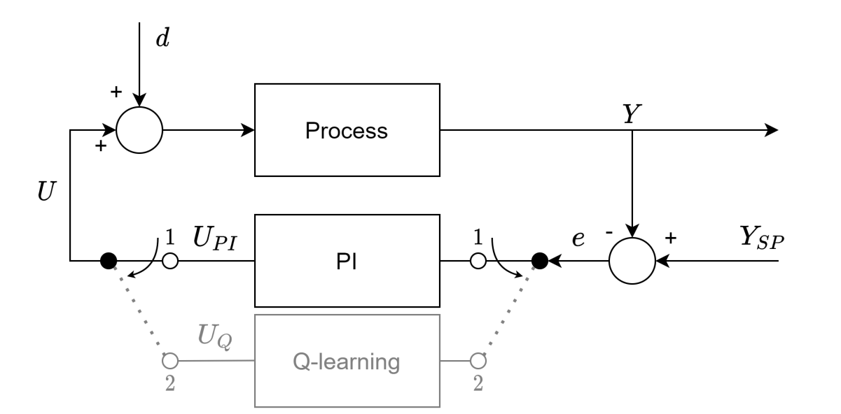
Fig. 1. Schematic diagram of the considered closed-loop control system. Initially, the system is operated by the conventional poorly tuned PI controller. After substituting with the Q-learning algorithm, it is designed to ensure self-improving properties by online learning via interaction with a Process.

For this paper, it is assumed that the Process has an unknown time-invariant second-order dynamics, which is more complex and more challenging for the control compared to the frequently considered simple first-order dynamics. It is also assumed that there is no time delay in the Process dynamics, which stands as a practical limitation. However, even without time delay, second-order dynamics still covers a broad class of industrial processes, including drive systems, extensively well-mixed biochemical reactors, heat exchange, distribution processes in well-mixed tanks, etc. The application of the Q-learning algorithm to control processes with a time delay is an important practical challenge that still remains unsolved. This problem is shortly discussed in Section 6 since it is one of the most currently followed future research directions. The only accessible information about the existing closed-loop control system is the tuning of the existing PI controller; this is the information that should be used for the initialization of the Q-learning algorithm. It is also assumed that the design of the Q-learning controller should map the predefined and fixed sets of discretized states [s] and admissible actions [a].
The majority of the industrial closed-loop systems are designed to ensure stabilization with highly infrequent changes for the setpoint Y_{sp}. Consequently, it is possible to assume that, for such cases, closed-loop systems are naturally and intensively disturbed by external disturbing signals varying within a certain range. Potentially, this situation is favorable in terms of the requirement of continuous excitation of the closed-loop system, which is critical for proper online learning. Thus, when the variations of the natural disturbances are frequent and significant, there is no need to introduce any additional excitation signals intentionally, only to enable effective learning. Thus, in this paper, for a realistic representation of the industrial conditions, the learning abilities of the Q-learning algorithm are tested only in the presence of the changes of the load disturbance Δd with randomized amplitude successively applied to the closed-loop system. Readers interested in the results of the learning based on consecutive changes of the setpoint applied to the closed loop system are referred to [36], in which this issue is considered for Q3d.
Finally, following [36], for deriving the proposed Q2d, the control goal is defined to ensure that the closed-loop system preserves the predefined first-order reference trajectory of the control error decay defined as $F\left(e,\dot{e}\right)=\dot{e}+(1/T_{e})e$, with e denoting control error and T_{e} signifying the time constant of the target. This statement of the control goal enables the preservation of the user-defined closed-loop performance with acceptable robustness.

3. Q2D APPROACH TO Q-LEARNING CONTROLLER DESIGN
As stated above, the concept of the proposed Q2d approach is still defined based on the closed-loop first-order reference trajectory defined as a target (goal) state in the same way as for Q3d [36] so that:
$F\left(e,\dot{e}\right)=\dot{e}+\left(1/T_{e}\right)e=0$. (2)
For Q3d, separate state spaces were defined both for the control error and for its derivative, which results in a 3-dimensional Q matrix. For the proposed Q2d, based on Eq. (2), the dimensions of the Q-matrix are reduced by merging its values separately, thus representing values of error and its time derivative into a single state. This method of defining the state significantly simplifies the subsequent initialization of the Q-matrix based on the required similarity with the existing PI controller. If the output of the PI controller is defined by the recursive formula:
$∆U_{PI}=K_{PI}∙T_{s}\left(\dot{e}+\left(1/T_{I}\right)e\right)$, (3)
where K_{PI}, T_{I}, and T_{s}, respectively, denote the PI gain, integral time, and sampling time, then the control output for the designed Q2d can be expressed similarly as:
$∆U_{Q}=K_{Q}∙T_{s}∙s$, (4)
where K_{Q} denotes the adjustable gain of the Q-learning controller, and s denotes the state of the closed-loop system, which can be determined as:
$s=\dot{e}+\left(1/T_{I}\right)e$, (5)
and then, after assuming K_{Q} = K_{PI}, the similarity between formulas (3) and (4) becomes apparent.
Apart from the similarity between Eqs. (3) and (4), there is another similarity between the PI and Q2d controllers. This similarity results from the same input-output specification, which can be seen in Fig. 1. Both controllers require the same information about current value of the control error e and both need the on-line numerical calculation of its current time derivative $\dot{e}$ to determine the value of the controller output. However, apart from these two similarities, they are very different from each other. The output of PI controller is always calculated directly using Eq. (3) and, in its conventional form, it does not have any learning properties because its performance is determined by the constant tunings K_{PI}, T_{I} adjusted by a user. Without any retuning, this performance remains the same from the very beginning of operation. There are some adaptive techniques that could be used to retune the PI controller according to variations in the process dynamics but these techniques require on-line retuning based on the predefined deterministic scheduling (retuning) function. If the PI controller was to have learning properties, it would have required using a learning technique to update scheduling function on-line. Contrary to the PI controller, the controllers based on Q-learning technique (such as e.g. the proposed Q2d approach) determine its current output using the Q-matrix whose elements clearly couple states (defined by Eq. (5) using e and $\dot{e}$) with all accessible actions. The sets of states and actions are the same but in exploration mode, Q-learning controller improves its performance by on-line learning, that is by selecting optimal actions and coupling them with corresponding states by updating the elements of Q-matrix. Thus, its operation is rather based on selecting the action from the predefined set of actions than on its deterministic calculation as it is done for the PI controller. The initial operation of Q-learning controller is determined at the initialization stage but in general it can be very far from optimal. At the same time, tuning of the Q-learning is very different from PI tuning. For the latter, tuning rather corresponds to the PI performance while for Q-learning controller, tuning corresponds to adjusting its learning abilities. Finally, Q-learning controller is superior to the PI controller due to its built-in learning abilities.
The proper creation of the state space and the corresponding action space is crucial [39]. They can be completed in various ways depending on the implementation capabilities and the expected accuracy of the control after the learning stage. The rule of thumb is that increasing the number of states enables a more accurate distinction between system states and, consequently, more precise control; however, at the high price of learning time and memory usage (a larger Q-matrix size). In the Q3d approach, the state space was created to ensure similarity to the conventional PI controller, which facilitates the initialization of the Q-matrix. Then, the resulting 3-dimensional Q-matrix with a large size is created with separate vectors for actions, error state, and error derivative state. This procedure was parametrized using four parameters with an uneven state distribution becoming denser for small absolute values of the control error to provide more accurate control when the system reaches the goal state given by Eq. (2).
In this paper, a new Q2d approach is proposed to reduce the number of parameters required for efficient parameterization to only two, without significant loss of accuracy. In addition, the state-creating process is significantly simplified. After a general definition of the state value s, as given by Eq. (5), this value must be discretized to derive the boundaries of each interval in the state space. It is based on determining two vectors of the discretized values of the control error and its time derivative. This procedure can be carried out in different ways depending on the requirements. In this paper, this discretization is based on assuming an exponential trajectory of the control error decay, which ensures that the accuracy of the state distinction increases as the absolute value of the control error decreases. This trajectory is parameterized by the parameter τ that defines the decay ratio and, consequently, the number of distinguished intervals. Discretization is applied for positive error values using the procedure that follows:

Listing 1:
i=0, t=0
REPEAT
INC(i), t = t+T_{s}
$$e_{i}=e_{max}∙exp\left(-t/τ\right)$$
$${\dot{e}}_{i}=\left(e_{max}/T_{s}\right)∙exp\left(-t/τ\right)$$
UNTIL ${\dot{e}}_{i}+\left(1/T_{I}\right)e_{i}$ < precision
i_{max} = i,

and the values of $e_{max}$and precision should be chosen according to the technological requirements and expected precision of control. Parameter $e_{max}$defines the maximum expected value of the control error that can occur in the control system. Thus, it enables the initialization of the control error variation within the range $±e_{max}$. Parameter precision directly defines the precision of reaching the goal state (2).
After completing the discretization procedure, the two vectors [e_{i}] and $[{\dot{e}}_{i}]$ are computed, and both vectors are the same size i = 1...i_{max}. Then, boundaries of state intervals s_{k} are also computed based on the vectors [e_{i}] and $[{\dot{e}}_{i}]$:

Listing 2:
k=0,
FOR i=1 to i_{max}
FOR j=1 to i_{max}
INC(k)
$s_{k}={\dot{e}}_{j}+\left(1/T_{I}\right)e_{i}$
k_{max} = k.

Potentially, such computed k_{max} boundaries can define state intervals that are very small and whose boundaries are extremely close, so, in practice, they can be indistinguishable. This fact can significantly limit the learning abilities of the Q2d controller. Thus, state intervals that are close with a predefined accuracy (e.g., one that can use previously defined precision parameters) are merged, which results in N < k_{max} distinguishable state intervals. Finally, the vector of boundaries of these intervals should be extended symmetrically as a mirror image to include negative values that form the complete state set [s]. Thus, the goal state is always located in the middle of the vector and, for such a state space creation, the 2-dimensional (2N-1) × (2N-1) Q-matrix is created.
In the next stage, for generating the vector of the values of the admissible actions [a] for the Q2d method, the mean values [s^{m}] are calculated for each state based on its boundaries, which are given by:
$s_{i}^{m}=\left(s_{i+1}+s_{i}\right)/2$ for i = 1..(2N-1), (6)
and, based on Eq. (4), for the initialization stage with each state represented by its mean value $s_{i}^{m}$, a single action calculated as a_{i} = K_{Q}·T_{s}·$s_{i}^{m}$ is assigned, and after such initialization, these actions are identical to those that the PI controller would take in the same state computed by Eq. (5), with the accuracy of discretization. The correlation between the state and its assigned action is stored in the Q-matrix and, during online learning, this correlation dynamically varies due to the learning ability given by Eq. (1) to ensure improvement in the control performance.
The above procedure does not ensure that the goal state represents the desired reference trajectory given by Eq. (2). Thus, during the operation of the Q2d approach, the current value of the system state must be computed as:
$s=\dot{e}+\left(1/T_{e}\right)e$ , (7)
and then, for this state, the control signal given by Eq. (4) must be recalculated based on the action a_{i} using the current value of the control error e as:
${ΔU}_{Q}= a-e\left(1/T_{e}-1/T_{I}\right)$. (8)
The aforementioned state definition significantly facilitates the Q-matrix initialization ensuring bumpless switching between the operating PI controller and the proposed Q2d controller. Consequently, it enables a very simple initialization of the Q-matrix to provide an initial performance extremely close to the existing PI controller. This initialization simply consists in creating the Q-matrix as the identity one.
By definition, the proposed Q2d approach is based on the one-dimensional state space representation. Thus, the method of generating the state space presented above is designed directly for this approach. Similarly to Q3d approach, it starts from generating the discretized values of e, $\dot{e}$ (see Listing 1) but this generation and the consecutive steps are different in the following details.
- For Q3d, generating the intervals of e, $\dot{e}$ is determined based on the time constant of the reference trajectory T_{e}, which makes it dependent on the definition of the desired reference closed loop performance. When this performance remains unchanged, such an approach is satisfactory but when the user wants to change this performance during the operation of the Q3d controller (e.g. due to changes in the technological conditions or in the process dynamics), the value of T_{e} must be redefined accordingly and the stage of generating the state space must be repeated for the new value of T_{e}. For Q2d approach, generating of the state space does not depend on the value of T_{e}. Instead, the parameter τ defining the decay ratio is applied and its value can be constant and independent from some changes in T_{e} value. This feature makes the procedure of the state space generation proposed for Q2d independent from the important design parameter T_{e}.
- After generating of the discretized values of e, $\dot{e}$, for Q3d approach, merging the small state intervals is made separately for e and $\dot{e}$, while for the proposed method designed for Q2d approach, before merging, the generated vectors [e_{i}] and $[{\dot{e}}_{i}]$ are used to generate the one-dimentional state space by computing the boundaries of the state intervals (see Listing 2). Then, merging is applied but only for a one-dimentional vector [s_{k}].
- For Q3d approach, generating of the accessible actions a_{i} is based on the existing PI controller. Namely, the values of the accessible discretized actions are generated using the equation defining the PI controller. Then, at the stage of initialization, the coupling between previously generated states and the appropriate actions is made by the complete survey. When the suitable action was found as the one with the value closest to the action that would be taken by the PI controller for the same state, the unitary value is set in the corresponding Q-matrix value to ensure that, at the initial stage, Q3d controller will operate with the closed loop performance very close to the one obtained for the existing PI controller. Contrary to that approach, for Q2d, the values of the accessible actions are computed based on the mean values of the previously computed state interval (see Eq. (6)). This approach significantly simplifies the initialization stage because due to the straightforward relation between the state and the action, the initialization comes down only to adjusting unitary values at the diagonal of the Q-matrix.
This method of generating the state space and accessible actions designed for Q2d approach brings the benefits in terms of memory requirements that result from a direct reduction of the two-dimensional state space (that requires using three-dimensional Q-matrix) into the one-dimensional state space (that uses two-dimensional Q-matrix). Consequently, if one wants to ensure similar accuracy of the state and action spaces approximation for both Q3d and Q2d approaches, the following memory usage is required:
- for Q3d, approximately N² states must be stored, N² values must be stored for the accessible actions (separately for each discretized value of e) and N³ values must be stored in the three-dimensional Q-matrix;
- contrary, for Q2d approach, only N states must be stored, N values must be stored for the accessible actions and N² values must be stored in the two-dimensional Q-matrix.
This reduction is very significant and can be important for the implementation in the units with limited memory resources.
At the same time, the method of generating the state space and accessible actions designed for Q2d approach brings also the benefits in terms of computational complexity. The generation method itself ensures lower computational complexity, which results from the comparison between Q2d and Q3d given in two final bullet points above (merging the states after computing their boundaries instead of separate merging of the discretized values of e and $\dot{e}$, very easy initialization by simple adjusting of the Q-matrix using unitary values at its diagonal instead of the three-dimensional complete survey). Reducing the dimension of the Q-matrix for Q2d approach also results in reducing the computational complexity needed for finding the optimal action that should be applied to the process (the current state is determined by a single value computed by Eq. (7) and then only a single column of the two-dimensional Q-matrix must be searched for the highest Q-value). Finally, lower number of recognized states for Q2d approach allows for faster learning (which is shown in section 4) because for a successful learning, the closed loop system must be in each state at least several times. Thus, for Q2d, the smaller number of states speeds up learning significantly because for the same accuracy of the state space approximation, smaller number of iterations is required to ensure that each state is visited the same number of times.
From a practical viewpoint, reducing the dimensionality of the Q-matrix from the three dimensional matrix for Q3d to the proposed two-dimensional matrix for Q2d basically has only benefits that are highlighted above. The only small disadvantage is the necessity of recalculating the optimal action a resulting from the current form of the Q-matrix into the action directly applied at the Q2d controller output ${ΔU}_{Q}$ according to Eq. (8). This necessity results directly from the fact that for Q2d approach, the state is recognized by Eq. (5) and the same value of s can be obtained for a large number of combinations of the signals e, $\dot{e}$ so there is no direct match between a combination of e, $\dot{e}$ and the state value. This recalculation is not required for Q3d because there, the state is recognized in two-dimensional space directly from the values of e, $\dot{e}$. Thus, the optimal action indicated in the Q-matrix is the direct action that should be applied to the process.
Similar to the previous Q3d approach, the exploration/exploitation problem is solved for the Q2d scheme by using the ε-greedy method [40]-[41]. For possibly the fastest learning in the exploration stage, the range of randomized actions should be unlimited, which is unacceptable in industrial practice when learning must be carried out based on a normal operating process. Thus, the range of drawing actions is limited by the parameter RD (for details, see [36]), which defines the limits of the range of draws around the optimal action represented by the highest value in the Q-matrix. The smaller the RD, the lesser the disturbances that are intentionally applied to the controlled process during learning in normal operations, but at the price of extending the learning time. In addition, in the situation when the desired reference trajectory is very different from the trajectory ensured by the existing PI controller, for too small value of RD (compared to the total number of states 2N+1) the learning process can be extremely slow. This results from the fact that the Q-learning controller needs to reach the goal state for correct learning, but when none of the potentially drawn actions brings the process to the goal state, the algorithm is unable to provide efficient learning conditions.
According to the ε-greedy method, in each iteration of the Q-learning algorithm, a real value A from the range 0-1 is drawn. When A < eps (where the value eps is user-predefined within the range 0-1), the algorithm switches to the exploration stage; in the opposite situation, the exploitation stage is selected and the action with the highest value in the Q-matrix is applied to the process. Thus, by proper adjustment of eps, it is possible to adjust how frequently the Q-learning controller switches between exploration and exploitation. Similar to the choice of RD, the higher the eps, the faster the learning process, at the expense of the frequency of applying disturbances (not optimal but drawn actions) to the process. Note that, for a relatively large value of eps, it is possible to successively apply several drawn actions instead of optimal ones, which significantly disturbs the process.
For optimal clarity, the sequence of consecutive operations for the Q2d method is presented in Fig. 2.

Fig. 2. Flowchart representing the sequence of operations in the Q2d method.
Summarizing, the proposed approach is based on on-line learning, which is meant here as the ability of improving its control performance only by interaction with the real process, without any learning taking place offline without interaction with the real process (e.g. using experts knowledge, simulation based on a process model, etc.). Namely, the proposed Q2d controller bumplessly starts its closed loop operation with the initial performance defined at the initialization stage based on the tunings of the operating PI controller and the procedure described above. Then it should normally operate in the closed loop system ensuring similar or (after a period of learning) better control performance comparing to the previously operated PI.
The process of on-line learning can be modified by a user by adjusting its settings.
- It is expected that the improvement taking place due to online learning requires only very minimal modifications of the normal operation. This difference in operation only comes down to a small modification of the optimal action (drawing of the action in the exploration mode withing the user adjustable range ± RD actions). Thus, RD appears as a very important setting of the on-line process. It should be adjusted very carefully to avoid too excessive disturbances introduced to the closed loop system only by online learning itself. It is suggested to start with a small value of RD and when learning is considered to be too slow, this value can be increased gradually but still with a high caution.
- Drawing of actions is strongly correlated with the exploration/exploitation problem. For Q2d, it is proposed to use the ε-greedy method and the user can adjust the value of eps within the range 0-1. It is recommended to adjust the value of this parameter with the same caution that was suggested for RD. In fact, separate increment of RD or eps potentially leads to a similar result: faster learning at the price of more excessive intentional disturbing of the closed loop system but applying actions different than optimal. However, while increasing RD results in the increase in the amplitude of these intentional disturbances (which potentially can be more dangerous for the closed loop operation), increase of eps influences only intensity of the intentional disturbances.

4. SIMULATION VALIDATION OF THE Q2D APPROACH
In the first stage of validation, the performance of the Q2d method is verified by simulations based on three stable SISO processes: $K_{1}\left(s\right)=\frac{1}{(1+2s)(1+5s)}$, $K_{2}\left(s\right)=\frac{1}{{\left(1+5s\right)}^{2}}$ and $K_{3}\left(s\right)=\frac{1}{5s^{2}+2s+1}$. Here, K₁ is a second order system with two different time constants, K₂ represents second-order dynamics with two equal time constants and K₃ is oscillatory. Especially the last two systems are relatively difficult to control comparing to the simple first order systems or to the second order systems with significantly different time constants, especially if the reference trajectory is defined as the first-order dynamics. Note that preserving the first order closed loop reference trajectory for the second order processes is possible only with properly tuned PID controller. Thus, the presented simulation results show how the proposed Q2d controller preserves the first order trajectory for the closed loop systems with the difficult second order processes after replacing the existing PI controller that cannot ensure such behavior even after retuning.
During the simulation experiments, for each K₁, K₂ and K₃ processes, the same tunings for the existing PI controller are assumed, which are the example default tunings used for Siemens PLC-based PI controller: K_{PI} = 1 and T_{I} = 20. Due to differences in the dynamics between considered processes, realistic reference trajectories are defined: T_{e} = 8 for K₁, T_{e} = 15 for K₂ and T_{e} = 10 for K₃.
The learning process is divided into learning cycles called epochs. The learning epoch is defined as starting from a moment when a single randomized load disturbance is applied until this disturbance is totally rejected or a maximal epoch length (set as 2000 samples) is reached. For a realistic representation of the industrial conditions, the learning abilities of the Q-learning algorithm are tested based only on successive changes of the load disturbance Δd applied to the considered closed-loop system with amplitude randomized within the range (-0.5, 0.5). Note that these disturbance changes simulate the real operating conditions when the process is intensively disturbed in a natural way; the control system is designed to reject these disturbances. Thus, the proposed concept of Q2d does not require the intentional application of any disturbances except for those that occur naturally.
First, the performance of the Q3d procedure with the 3-dimensional Q-matrix (as presented in [36]) is compared with the proposed Q2d. For both Q3d and Q2d, corresponding Q-matrices are defined, and their dimensions show the scale of reduction between Q3d and Q2d; the size of the Q-matrix is reduced from 3 dimensions (i.e., 191×321×321) for Q3d to only 2 dimensions (105×105) for the proposed Q2d. For both Q3d and Q2d, the corresponding Q-matrices are initialized using the methods proposed for the respective algorithms (Q3d in [36]) and Q2d is proposed in this paper) to ensure initial Q-learning performance very close to the existing PI controller. The other parameters of the Q-learning algorithms are adjusted in the same way: eps = 0.3, α = 0.1, and γ = 0.99.
The example results of the Q-matrix initialization, after 5000 epochs of online learning for a closed-loop system with K₁ process, are presented in Fig. 3. The results are obtained for RD = 10, for both the Q-learning controllers, and T_{s} = 0.5 for Q3d and T_{s} = 0.1 for Q2d. In both cases, the initialization process ensures closed-loop behavior very close to the PI controller; therefore, the switching between the existing PI controller and each of the considered Q-learning controllers is practically bumpless. However, after online learning, the differences between both Q-learning controllers are apparent. Apart from a highly substantial reduction in the size of the Q-matrix for the Q2d method, it ensures faster learning that leads to very good closed loop performance after 5000 learning epochs. Namely, tracking matches assumer reference trajectory very accurately, while disturbance rejection is also very good, in terms of a very significant reduction of both overregulation and regulation time. At the same time, after the same number of learning epochs, tracking significantly improves, but the disturbance rejection is clearly improved only for regulation time, without any reduction of overregulations.

A.
B.
Fig. 3. Comparison of the Q3d (diagram A) and Q2d (diagram B) approaches for a K₁ process after 5000 learning epochs. QwL represents the respective Q-learning algorithm that is initialized based on PI tunings and QL performance after 5000 epochs of learning.

These conclusions are further confirmed by the changes in the normalized increment of the norm Δ_{N} of the Q-matrices for the Q3d and Q2d approaches, presented in Fig. 4. This increment is calculated every 100 learning epochs as:
$∆_{N}\left(n\right)=\left|\frac{{\left\|Q\right\|}_{2}\left(n\right)-{\left\|Q\right\|}_{2}\left(n-100\right)}{{\left\|Q\right\|}_{2}\left(100\right)-{\left\|Q\right\|}_{2}\left(0\right)}\right|$, (9)
where ${\left\|Q\right\|}_{2}\left(n\right)$ denotes the 2-norm of the Q-matrix (for Q3d, this is calculated for all three dimensions), computed after n learning epochs; ${\left\|Q\right\|}_{2}\left(0\right)$ denotes the square norm calculated for the Q-matrix after initialization based on PI tunings.
During the learning process, the values in the Q-matrix should converge to certain values representing the optimal (reference) closed-loop performance. Consequently, Δ_{N} should converge to zero, which indicates that further learning is not necessary if the process is time-invariant. Next, the Q-learning controller can be switched into exploitation mode and operate normally. Fig. 4 shows that, for Q2d, this occurs after ≈ 1200 learning epochs, while at the same time, for Q3d, there is a very small drop in the increment of the norm, even after 5000 learning epochs, which shows that the online learning should be continued in this case. This fact is additionally justified by analyzing the lines of trend for both Q3d and Q2d. For Q3d, the blue line of trend goes down monotonically over the whole considered learning period. At the end of this it seems that the same negative tangent (-0.0035) will be preserved. However, there is no need to analyze longer learning period because for Q2d, two lines of trend should be used to present two stages. At the beginning, comparing to Q3d, faster learning takes place with significantly higher negative tangent (-0.083 for Q2d vs. -0.0035 for Q3d). Then, this negative tangent significantly drops down (from
-0.083 to -8.67e-04), which clearly indicates that further changes in Q-matrix are very small and learning can be considered as completed after approximately 1200 learning epochs.

Fig. 4. Variations of the increment of the norm for Q3d and Q2d, defined by Eq. (9) for the experiment shown in Fig. 3, over a period equivalent to 5000 learning epochs. Line of trend for Q3d is represented by blue line while two red lines represent two separate lines of trend for Q2d, for two stages: effective learning (between 0 and appr. 1200 learning epoches) and the stage in which Q2d can be considered as optimal in terms odf the desired closed loop reference trajectory (after 1200 learning epoches).
Results of the comparison between the Q3d and Q2d methods for the closed loop system with K₂ and K₃ processes are quantitatively different but qualitatively lead to the same conclusions. Thus, the proposed Q2d approach provides not only a significant reduction in the memory and computation power demand but also significantly speeds up the learning process due to the proposed reduction.

A.
B.
Fig. 5. Improvement in the control performance after a different number of learning epochs for the Q2d and K₁ processes for small variation of d = ± 0.3. “Initialization” represents the performance of the Q2d method after initialization based on the existing PI tunings, without learning. Next, the learning results are shown after the listed number of the learning epochs. Diagram (A) represents variations of the controlled variable Y while diagram (B) variations of the manipulating variable U.

A.
B.
Fig. 6. Improvement in the control performance after a different number of learning epochs for the Q2d and K₂ processes for small variation of d = ± 0.3. “Initialization” represents the performance of the Q2d method after initialization based on the existing PI tunings, without learning. Next, the learning results are shown after the listed number of the learning epochs. Diagram (A) represents variations of the controlled variable Y while diagram (B) variations of the manipulating variable U.

A.
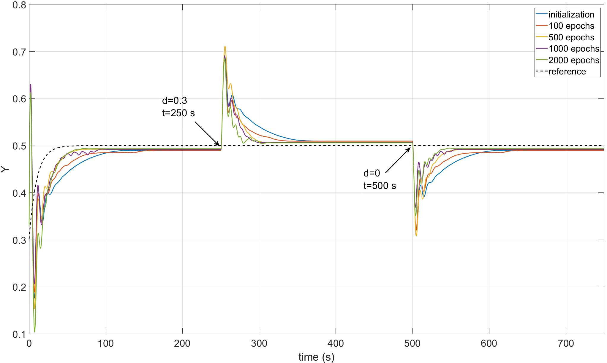
B.
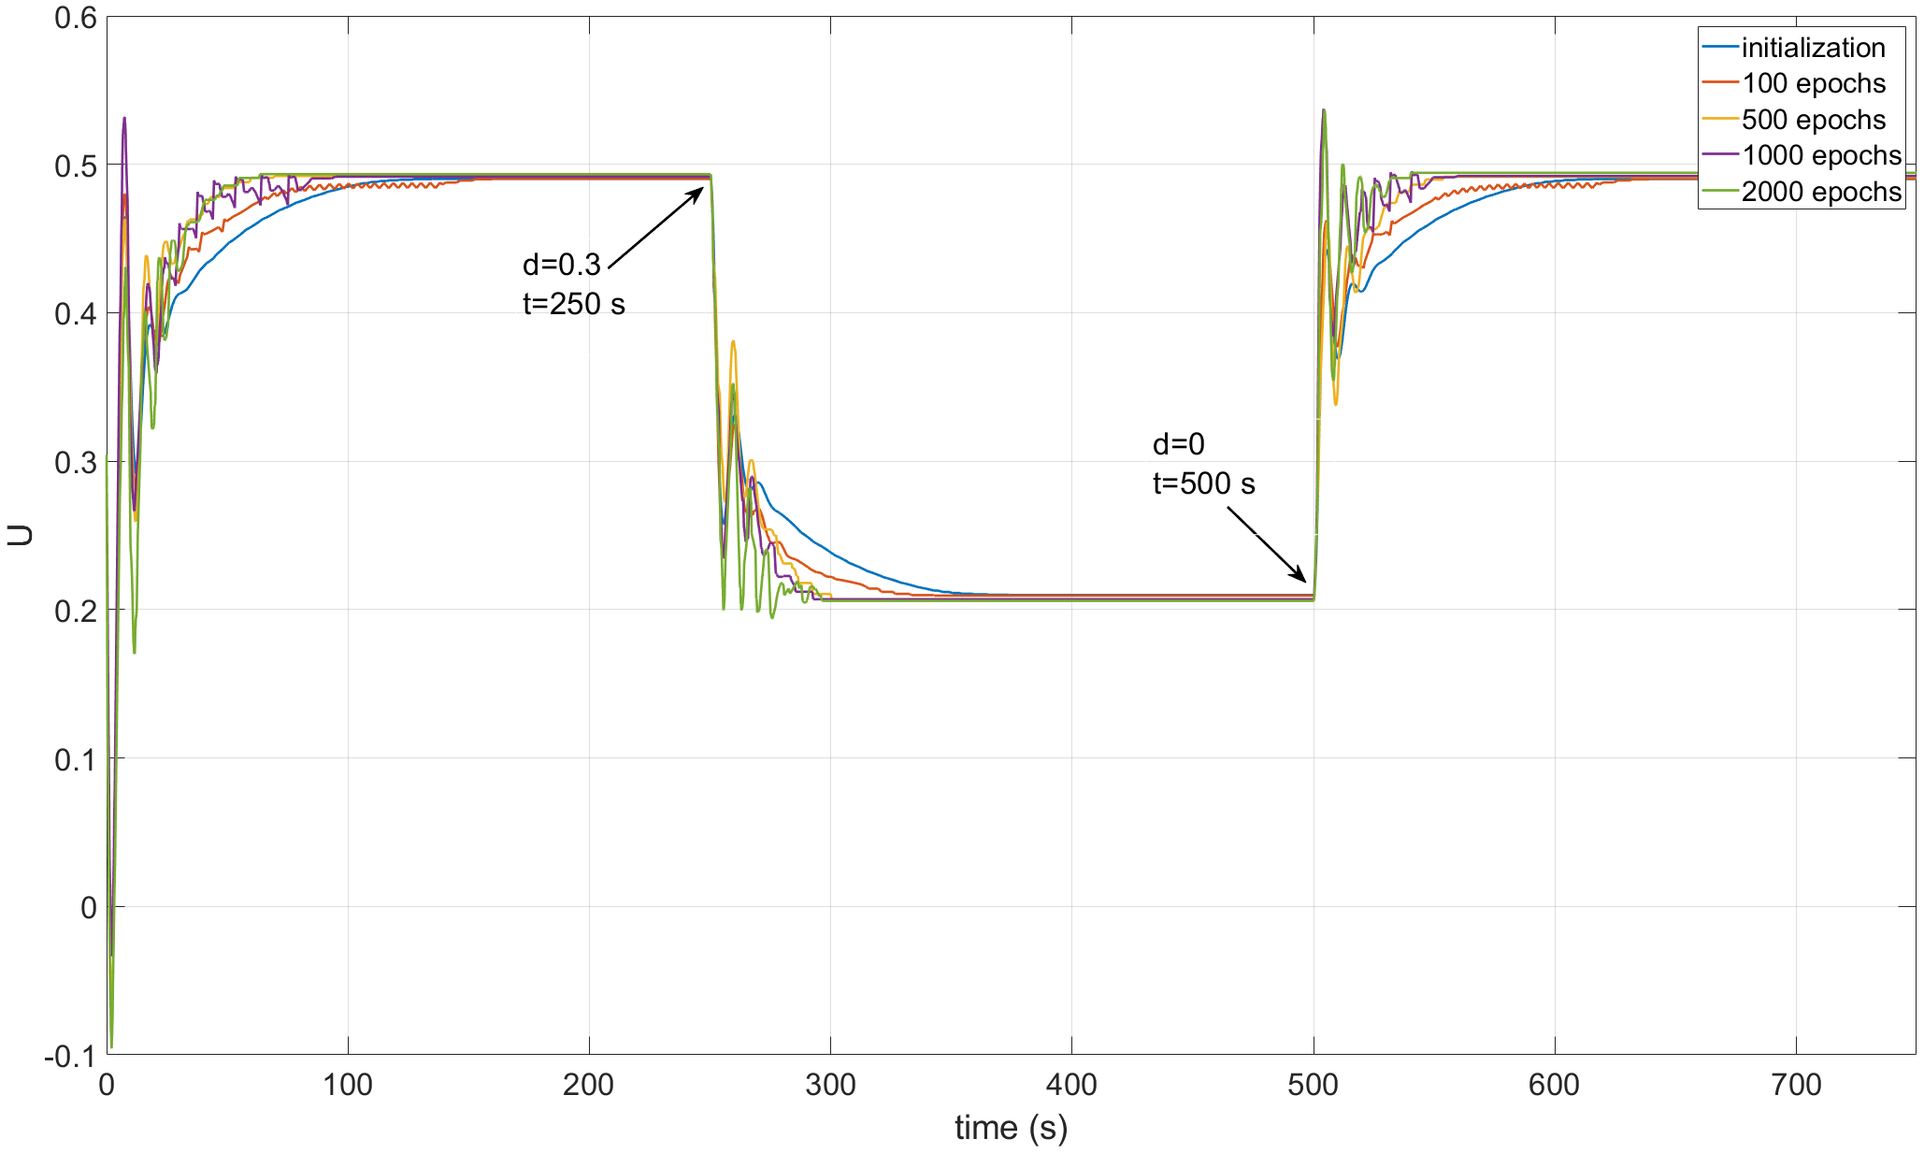
Fig. 7. Improvement in the control performance after a different number of learning epochs for the Q2d and K₃ processes for small variation of d = ± 0.3. “Initialization” represents the performance of the Q2d method after initialization based on the existing PI tunings, without learning. Next, the learning results are shown after the listed number of the learning epochs. Diagram (A) represents variations of the controlled variable Y while diagram (B) variations of the manipulating variable U.

In the next stage, the performance of the Q2d method is validated for K₁, K₂ and K₃ processes. As previously stated, the Q-matrix is initialized based on the tunings of the existing PI controller using the proposed method. RD is adjusted differently depending on the process: RD = 10 for K_{1,} RD = 5 for K₂ and RD = 2 for K₃. This difference in RD values is due to the alteration in the dynamics for each considered process.
Figs. 5 - 7 show the results of the online learning after a different number of learning epochs. The results are presented by validation experiment that consists of an initial single set point step change and two consecutive step changes of the disturbance with the small amplitude d = ± 0.3 that is smaller than the amplitude of changes of d used during on-line learning. Thus, these results correspond to the case when the amplitude of the disturbances changes applied during validation experiments are within the scope of amplitudes (d = ± 0.5) applied during online learning. For K₁, K₂ and K₃ processes, even after only a few hundred epochs, a significant improvement over the PI controller performance is evident for the proposed Q2d approach. Namely, for the disturbance rejection, the settling time is successively reduced and additionally for K₁, K₂ processes, one can also observe a successive reduction of overregulation. At the same time, the tracking becomes increasingly closer to the reference trajectories predefined for the closed loops with each considered process. Note that, due to defining the parameter precision = 0.01, the Q2d method does not eliminate the steady-state error. Instead, this error is kept constant at a level corresponding to the predefined precision, which is a characteristic feature of the proposed Q-learning approach. However, for a reasonably chosen precision, this phenomenon is acceptable in the majority of practical cases. The improvement is a result of the successive learning of more aggressive operation, which can be observed in the corresponding diagrams showing variations of the manipulating variable. Simultaneously, due to the obvious difference in the dynamics between the predefined first-order reference trajectory and the dynamics of the considered second order processes, the difference between the reference trajectory and the variations of the process output after the learning is still visible.
Table I shows the chosen quantitative quality measures computed for the experiments shown in Figs. 5-7. For this purpose, four measures that are the most frequently used in control engineering practice are proposed. First is the integral absolute error (IAE) that quantifies the absolute value of the control error by its integration over a certain period of time. For changes of the set point, it quantifies tracking properties while for changes of disturbances, it quantifies how the disturbance is rejected over time. This measure is a very general but not fully informative. Thus, it should be used jointly with the other measures. The second one considered here is the maximal overshoot - namely, the maximum absolute value of over or undershoot of the controlled output Y over (for a positive change) or under (for a negative change) of the set point. The third one is the settling time that quantifies how long it takes to reach the new steady state after the set point change (tracking) or to fully reject the disturbance after its appearance. Finally, the maximal increment of the manipulating signal $\left|ΔU_{max}\right|$ is used as the fourth considered measure. It is used to quantify the price in terms of aggressivity of the control action. More precise control (with smaller values of IAE, maximum overshoot and settling time) requires more aggressive action (larger increments of the manipulating signals and consequently larger $\left|ΔU_{max}\right|$). However, too aggressive actions can lead to oscillatory closed loop behavior or even instability of the closed loop system. These measures are not only the most frequently used in the industrial automation for the assessment of the closed loop control performance, but they are also used as quality performance indicators that should be minimized by optimal PI tuning. Namely, some analytical tuning rules for a PI controller have been designed to minimize IAE (or its equivalent ISE – integral square error), maximum overshoot or settling time for a class of closed loop systems, based on more or less precise knowledge of the mathematical process model [42]. At the same time, $\left|ΔU_{max}\right|$ sometimes can be used for analytical calculation as the penalty function for minimization of the chosen quality indicator to prevent from too aggressive closed loop behavior.
The values of the quality indicators shown in Table I separately for tracking after a set point change and two consecutive disturbance rejections as well as for each considered process confirm previous observations. The best (smallest) values are bolded. For each process, initialization is accurate which can be seen by practically the same values of each considered quality measures. Then, after consecutive stages of on-line learning, for both processes, IAE values decrease both for tracking and for two disturbance rejections. For K₂, this decrease is a clearly monotonic function over the learning period. For K₁ and K₃, there are some irregularities in the monotonicity of this decrease for tracking and the first disturbance rejection but these irregularities are not very significant from a practical viewpoint, especially in the context of changes of the other three quality indicators. Maximum overshoot for tracking is practically the same for each process over the learning period while its values significantly decrease for both disturbance rejections for K₁ and K₂ processes. For K₃ process, there are some irregularities visible again for disturbance rejections but still these irregularities are very small and thus not significant from a practical viewpoint. Practically, settling time monotonically decreases for each considered process regardless of whether it is calculated for the tracking or for any of two disturbance rejections. Finally, as it was expected, $\left|ΔU_{max}\right|$ monotonically decreases for each process and for both tracking and disturbance rejections showing the price in more aggressive control actions.

TABLE I
Quality indicators for Quantitative Measure of Improvement in Control Performance for Q2d and three Considered Processes, for Small Variation of Disturbance (± 0.3)

process K₁
 | IAE  for step changes of |  |  | max. overshoot  for step changes of |  |  |  |  | settling time  for step changes of |  |  |  | $$\left|ΔU_{max}\right|$$  for step changes of
 | Y_{sp} | d = 0.3 | d = 0 |  | Y_{sp} | d = 0.3 | d = 0 | Y_{sp} |  | d = 0.3 | d = 0 | Y_{sp} |  | d = 0.3 | d = 0
PI | 7.84 | 5.66 | 5.59 |  | 0.00 | 0.14 | 0.14 | 109.10 |  | 101.50 | 101.10 | 0.001 |  | 0.003 | 0.003
QwL | 7.95 | 5.51 | 5.52 |  | 0.01 | 0.13 | 0.13 | 111.00 |  | 102.70 | 102.80 | 0.001 |  | 0.003 | 0.003
100 | 3.41 | 2.36 | 2.32 |  | 0.01 | 0.09 | 0.11 | 31.40 |  | 45.00 | 30.10 | 0.004 |  | 0.010 | 0.005
500 | 1.88 | 1.24 | 1.67 |  | 0.00 | 0.08 | 0.06 | 20.70 |  | 13.70 | 12.00 | 0.024 |  | 0.008 | 0.028
1000 | 2.91 | 1.15 | 0.68 |  | 0.01 | 0.05 | 0.08 | 16.60 |  | 7.40 | 12.70 | 0.010 |  | 0.073 | 0.013
2000 | 2.18 | 1.32 | 0.64 |  | 0.01 | 0.02 | 0.05 | 13.10 |  | 8.80 | 9.90 | 0.017 |  | 0.118 | 0.020
process K₂
PI | 8.34 | 6.20 | 6.29 |  | 0.00 | 0.12 | 0.12 | 72.20 |  | 89.50 | 89.30 | 0.001 |  | 0.001 | 0.001
QwL | 8.72 | 6.59 | 6.71 |  | 0.01 | 0.12 | 0.13 | 70.90 |  | 88.50 | 88.50 | 0.001 |  | 0.001 | 0.001
100 | 5.36 | 6.76 | 4.44 |  | 0.02 | 0.12 | 0.10 | 76.40 |  | 95.40 | 70.80 | 0.008 |  | 0.001 | 0.002
500 | 8.37 | 3.34 | 3.68 |  | 0.01 | 0.08 | 0.09 | 59.30 |  | 96.40 | 91.60 | 0.002 |  | 0.005 | 0.002
1000 | 5.58 | 1.62 | 2.29 |  | 0.01 | 0.03 | 0.07 | 67.20 |  | 58.30 | 44.50 | 0.006 |  | 0.007 | 0.004
2000 | 5.12 | 1.22 | 2.06 |  | 0.00 | 0.03 | 0.06 | 57.40 |  | 57.90 | 44.60 | 0.017 |  | 0.017 | 0.017
process K₃
PI | 8.44 | 5.97 | 5.98 |  | 0.13 | 0.20 | 0.20 | 90.70 |  | 76.60 | 76.40 | 0.029 |  | 0.006 | 0.006
QwL | 8.86 | 6.56 | 6.56 |  | 0.13 | 0.19 | 0.19 | 87.00 |  | 73.50 | 73.00 | 0.027 |  | 0.007 | 0.007
100 | 7.91 | 5.18 | 5.57 |  | 0.13 | 0.18 | 0.18 | 72.40 |  | 55.40 | 57.40 | 0.027 |  | 0.007 | 0.010
500 | 6.31 | 4.79 | 4.66 |  | 0.12 | 0.21 | 0.19 | 48.90 |  | 39.20 | 37.50 | 0.039 |  | 0.008 | 0.009
1000 | 6.46 | 4.10 | 3.41 |  | 0.13 | 0.19 | 0.13 | 65.20 |  | 33.00 | 33.20 | 0.026 |  | 0.013 | 0.018
2000 | 7.14 | 3.22 | 2.93 |  | 0.11 | 0.18 | 0.14 | 48.10 |  | 25.50 | 27.50 | 0.046 |  | 0.016 | 0.015
best (smallest) values are bolded for each case
Results presented above confirm the improvement in the closed loop control performance over the on-line learning period for the considered closed loop systems with the processes K₁, K₂ and K₃ quantified by the validation experiment including rejection of two consecutive disturbance step changes with the amplitude d = ± 0.3 that remains within the range of the amplitudes of the disturbance changes applied during the on-line learning process. Figs. 8-10 show the results when the validation was made using two consecutive step changes of the disturbance with the amplitude
d = ± 0.7 that is higher than the amplitude of changes of d = ± 0.5 used during the learning period. Consequently, these results show how the closed loop systems cope with disturbances with the amplitude exceeding the range of amplitudes of the disturbances applied during the on-line learning. Such cases can take place in practice when occasionally the disturbances with a larger amplitude than usually occur in the closed loop systems.
A.
B.
Fig. 8. Improvement in the control performance after a different number of learning epochs for the Q2d and K₁ processes for large variation of d = ± 0.7. “Initialization” represents the performance of the Q2d method after initialization based on the existing PI tunings, without learning. Next, the learning results are shown after the listed number of the learning epochs. Diagram (A) represents variations of the controlled variable Y while diagram (B) variations of the manipulating variable U.

A.
B.
Fig. 9. Improvement in the control performance after a different number of learning epochs for the Q2d and K₂ processes for large variation of d = ± 0.7. “Initialization” represents the performance of the Q2d method after initialization based on the existing PI tunings, without learning. Next, the learning results are shown after the listed number of the learning epochs. Diagram (A) represents variations of the controlled variable Y while diagram (B) variations of the manipulating variable U.

A.
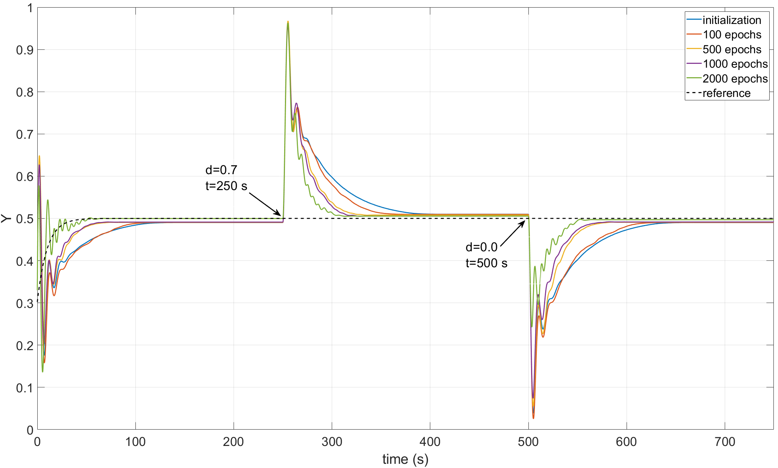
B.
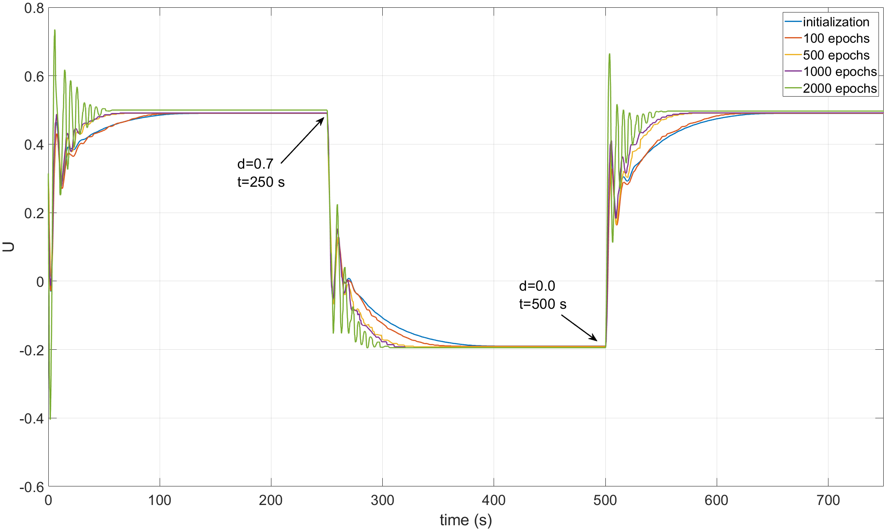
Fig. 10. Improvement in the control performance after a different number of learning epochs for the Q2d and K₃ processes for large variation of d = ± 0.7. “Initialization” represents the performance of the Q2d method after initialization based on the existing PI tunings, without learning. Next, the learning results are shown after the listed number of the learning epochs. Diagram (A) represents variations of the controlled variable Y while diagram (B) variations of the manipulating variable U.

For K₁ process (Fig. 8), practically the same improvement in the control performance is observed as for the case with smaller disturbances changes (d = ± 0.3, see Fig. 5). The influence of the larger amplitude of d = ± 0.7 results in larger changes in the controlled output Y but the trend in the improvement in the closed loop control performance is preserved. At the same time, variations of the corresponding changes of the manipulating variable U for K₁ process become more oscillatory, especially after a longer period of the on-line learning. Oscillatory behavior increased significantly for the closed loop system with K₂ process (Fig. 9), which is particularly visible in the variations of the manipulating variable U. Its oscillatory behavior increases with the learning period but the corresponding variations of the controlled output Y are still acceptable and, in these terms, they are not very different from those observed in Fig. 5 for d = ± 0.3. For K₃ process (Fig. 10), again, the trend in the improvement in the control performance is preserved comparing to the case shown in Fig. 7 for d = ± 0.3. The variations of the controlled variable Y remain acceptable over the learning period even if for 2000 learning epochs, the variations of the manipulating variable U show a highly oscillatory character.

TABLE II
Quality indicators for Quantitative Measure of Improvement in Control Performance for Q2d and Three Considered Processes, for Large Variation of Disturbance (± 0.7)

process K₁
 | IAE  for step changes of |  |  |  | max. overshoot  for step changes of |  |  |  | settling time  for step changes of |  |  |  |  |  |  | $$\left|ΔU_{max}\right|$$  for step changes of
 | Y_{sp} | d = 0.7 | d = 0 | Y_{sp} |  | d = 0.7 | d = 0 | Y_{sp} |  |  | d = 0.7 |  | d = 0 |  | Y_{sp} |  |  | d = 0.7 |  | d = 0
PI | 7.84 | 13.37 | 13,03 | 0.00 |  | 0.33 | 0.32 | 83.90 |  |  | 107.5 |  | 106.7 |  | 0.001 |  |  | 0.007 |  | 0.007
QwL | 7.92 | 12.92 | 12,85 | 0.01 |  | 0.32 | 0.32 | 83.20 |  |  | 105.9 |  | 105.8 |  | 0.001 |  |  | 0.008 |  | 0.008
100 | 4.07 | 5.45 | 7.68 | 0.01 |  | 0.29 | 0.32 | 32.10 |  |  | 41.60 |  | 48.40 |  | 0.009 |  |  | 0.019 |  | 0.017
500 | 3.02 | 3.93 | 3.28 | 0.01 |  | 0.26 | 0.20 | 22.50 |  |  | 30.30 |  | 28.10 |  | 0.023 |  |  | 0.021 |  | 0.023
1000 | 2.61 | 2.98 | 2.68 | 0.00 |  | 0.18 | 0.13 | 22.70 |  |  | 24.40 |  | 18.50 |  | 0.031 |  |  | 0.083 |  | 0.08
2000 | 2.65 | 1.13 | 1.79 | 0.01 |  | 0.09 | 0.10 | 20.10 |  |  | 9.90 |  | 14.80 |  | 0.055 |  |  | 0.084 |  | 0.057
process K₂
PI | 8.35 | 14.72 | 14.72 | 0.00 |  | 0.28 | 0.28 | 65.40 |  | 90.70 |  | 90.40 |  | 0.001 |  |  | 0.002 |  | 0.002
QwL | 8.72 | 15.21 | 15.01 | 0.01 |  | 0.28 | 0.28 | 64.10 |  | 90.20 |  | 89.70 |  | 0.001 |  |  | 0.002 |  | 0.002
100 | 7.41 | 10.74 | 13.34 | 0.04 |  | 0.21 | 0.26 | 84.60 |  | 110.20 |  | 117.40 |  | 0.005 |  |  | 0.004 |  | 0.006
500 | 9.53 | 10.28 | 9.59 | 0.04 |  | 0.22 | 0.19 | 66.00 |  | 95.80 |  | 81.5 |  | 0.006 |  |  | 0.013 |  | 0.007
1000 | 6.23 | 5.82 | 7.27 | 0.03 |  | 0.11 | 0.18 | 52.00 |  | 90.70 |  | 68.00 |  | 0.035 |  |  | 0.041 |  | 0.035
2000 | 4.73 | 2.39 | 2.62 | 0.02 |  | 0.05 | 0.06 | 30.50 |  | 77.60 |  | 58.70 |  | 0.092 |  |  | 0.093 |  | 0.093
process K₃
PI | 8.44 | 13.96 | 13.95 | 0.13 |  | 0.47 | 0.47 | 90.70 |  | 109.80 |  | 109.50 |  | 0.028 |  |  | 0.016 |  | 0.016
QwL | 8.86 | 14.06 | 14.08 | 0.13 |  | 0.46 | 0.46 | 87.00 |  | 107.80 |  | 107.70 |  | 0.028 |  |  | 0.018 |  | 0.018
100 | 9.33 | 12.62 | 13.86 | 0.13 |  | 0.46 | 0.47 | 84.50 |  | 87.20 |  | 98.20 |  | 0.028 |  |  | 0.0178 |  | 0.018
500 | 6.58 | 9.77 | 10.04 | 0.15 |  | 0.47 | 0.44 | 49.70 |  | 60.30 |  | 59.30 |  | 0.031 |  |  | 0.032 |  | 0.018
1000 | 6.16 | 8.98 | 8.70 | 0.13 |  | 0.46 | 0.43 | 47.90 |  | 54.50 |  | 54.40 |  | 0.033 |  |  | 0.032 |  | 0.026
2000 | 2.55 | 7.13 | 4.48 | 0.08 |  | 0.46 | 0.26 | 33.60 |  | 43.90 |  | 40.30 |  | 0.110 |  |  | 0.038 |  | 0.039
best (smallest) values are bolded for each case

The conclusions which can be drawn on the basis of the results presented in Figs. 8-10 are confirmed after analyzing the values of the quality indicators shown in Table II and separately computed again for tracking after the set point change and two consecutive disturbance rejections with higher amplitude d = ± 0.7, for each considered process. The best (smallest) values are bolded. For these validation experiments and for each process, the initialization is still accurate which can be seen by practically the same values of each considered quality measures. Practically, IAE values decrease monotonically with the learning period for each process. Maximum overshoots also decrease along the learning period with a very small exceptions of tracking for K₁ and K₂ processes but even then, the differences in this measure are not significant from a practical viewpoint. Settling time for each case decreases monotonically and significantly and the price of more and more aggressive control actions are also visible for each process along the learning period.
Finally, simulation results show that the proposed Q2d ensures gradual improvement in the control performance for three closed loop systems with second order processes K₁, K₂ and K₃ even if each of them exhibits different dynamic properties. The results show that the closed loop system with the process K₂ is the most challenging which results from the fact that its dynamic properties are close to the first order system with a dead time. However, even then the improvement is clear and the results are acceptable from the practical viewpoint.

5. EXPERIMENTAL VALIDATION OF Q2D
In this section, the results of the experimental validation of the proposed Q2d method are presented, which show not only the final control performance after the learning but also its gradual changes at the different stages of the learning. Note that these changes are very important from a practical viewpoint because the Q2d approach should ensure not only the final improvement in the control performance but also even a lack of significant temporary degradation compared to the initial control performance with the existing PI controller.
The experiments were made using the setup shown in Fig. 11. This setup consists of three identical asynchronous motors M1 – M3 (SEW-Eurodrive DRS71S4/FI/TH/ES7C/LN 0.25kW), each controlled by the respective frequency inverters Inv1 – Inv3 (PowerFlex Compact Drive 525 AC). The first motor M1 represents the first-order dynamic and its rotation speed Y₁ can be directly adjusted by the frequency U₁ and is considered as the manipulating variable. This speed is measured and, after recomputing into the frequency U₂, is applied to the system of two motors, M2 and M3, coupled by the rigid shaft. This connection provides the second-order dynamics of the whole process because the rotation speed Y₂ of M2 is the controlled variable. The motor M3 is used as a load for the whole system and, when the rotation speed of M2 and M3 is the same (i.e., d = 0), the system operates without any load. Any difference in the speed rotation (for which d < 0, i.e., only the negative difference is acceptable due to the technical limitations) between M2 and M3 applies a load disturbance used for the excitation of the online Q2d learning.
The whole setup is directly operated by an Allen-Bradley PLC CompactLogix L16ER, programmed using Studio 5000 software and connected to frequency inverters. The communication between the PLC and PC is made with a local network via a TCP/IP protocol. The PI controller used for the comparison is implemented directly in the PLC using the standard PID library function block. Its tunings are adjusted as K_{PI} = 3.33 and T_{I} = 18. The Q-matrix and the vector of the accessible actions are generated and initialized using the method proposed in Section 3. The size of the Q-matrix is 105×105, but because the computation and memory requirements for the Q2d approach are still relatively high, it is implemented on a PC using Matlab R2022a environment. The parameters of the Q2d approach are adjusted as eps = 0.3, α = 0.1, γ = 0.99, T_{s} = 0.1 (sec), T_{e} = 6 (sec), RD = 10, and precision = 2 (rpm). The online learning is carried out by a successive excitation of the system by step changes of the load disturbance, which are randomized between its maximum value –3 (Hz) and minimum value 0 (Hz). Let us note once again that these disturbances have to be applied intentionally to simulate their natural occurrence that exists during the normal operation of the closed-loop system. It is due to technical limitations of the used laboratory setup, in which any natural disturbances do not occur. However, this approach do not make any significant limitation for the conducted experiments.

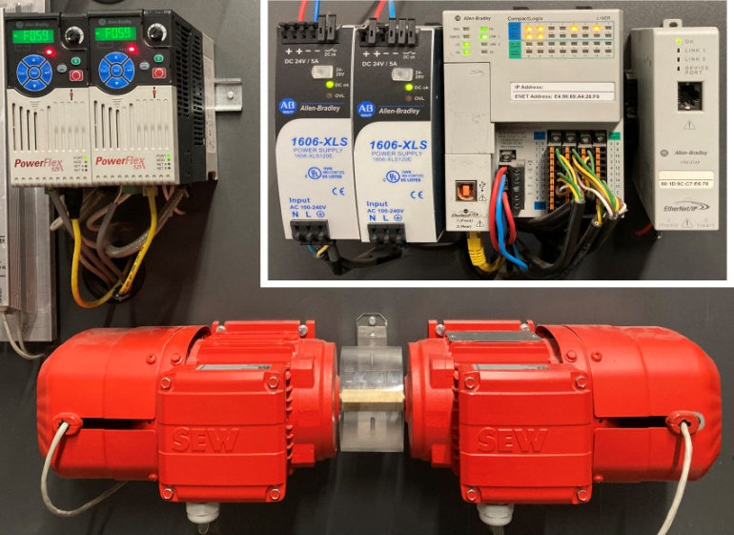
Fig. 11. Part of the experimental setup that includes motors M2 and M3, frequency inverters Inv 2 and Inv 3, and PLC (left figure) and a schematic diagram depicting the whole setup (right figure).

Fig. 12. Experimental comparison of the control performance for the existing PI controller and the Q2d approach after its initialization based on the existing PI tunings (QwL, without learning).

A.
B.
Fig. 13. Improvement in the control performance after a different number of learning epochs for the experimental validation of the Q2d approach. QwL represents the performance of Q2d after initialization based on the existing PI tunings, without learning. Next, the learning results are shown after the listed number of the learning epochs. Diagram (A) represents variations of the controlled variable Y while diagram (B) variations of the manipulating variable U.
The control performance of the Q2d method (after the proposed initialization) based on the tunings of the existing PI controller is presented in Fig. 12. Note that the accuracy of the initialization is acceptable, especially when the Q2d approach does not reject the control error to zero (its non-zero value is kept in a steady state according to the adjustment of precision). Readers should also note that, contrary to simulation validation, measurement noise exists in the experimental setup. Its impact is not extensive, but it definitely influences the control performance and the learning abilities of the Q2d approach.
Fig. 13 shows the results of the online learning for the Q2d approach after a different number of learning epochs. It is clear that a significant improvement occurs in terms of both tracking and disturbance rejection. Tracking becomes increasingly closer to the reference trajectory and the settling time is visibly reduced, even if the overregulations for the disturbance rejection do not change significantly.
These conclusions are additionally confirmed by the values of the quantitative measures such as the integral absolute error (IAE), maximal overshoot (namely, the maximum absolute value of over or undershoot), settling time, and the maximal absolute increment of the manipulating signal $\left|ΔU_{max}\right|$. Table III shows the variations of the values of these measures over consecutive number of learning epochs and separately for tracking and each of two disturbance rejections, starting from comparison between PI and Q2d directly after initialization. The best (smallest) values are bolded. The small differences at the initialization stage can be seen for each measure but the differences are not very important from a practical viewpoint (see Fig. 12). These differences are smaller comparing to the final closed loop improvement obtained for Q2d after 2000 learning epochs. For IAE measure, after initialization, Q2d starts with IAE value larger than PI for tracking and both disturbance rejections but during consecutive learning, IAE value decreases showing gradual improvement in the control performance over learning period. Note that especially for both disturbance rejections, the final drop in AIE value after 2000 learning epochs is very significant comparing to QwL (Q2d after initialization before online learning). Maximum overshoot for tracking and disturbance rejections practically remains the same over learning period. After learning, it only slightly increases comparing to the initialization stage but this increase is not important from a practical viewpoint and it may well be due to random measurement noise existing in the real system. On the contrary, the values of the settling time directly indicate significant improvement in the control performance over learning period for tracking and both disturbance rejections. Consequently, these experimental results show that it is possible to obtain the highest improvement in the settling time, which is a very important indicator, especially for disturbance rejection and for the same maximum overshoot. Variations of the $\left|ΔU_{max}\right|$ value confirm that the price of the improvement in the control performance is not very high (relatively small increment over learning period) and results from more aggressive actions taken by Q2d due to on-line learning.
TABLE III
Quality indicators for Quantitative Measure of Improvement in Control Performance for Q2d for Experimental Validation

 | IAE  for step changes of |  |  |  |  |  |  | max. overshoot  for step changes of |  |  |  |  | settling time  for step changes of |  |  |  |  |  |  |  |  | $$\left|ΔU_{max}\right|$$  for step changes of
 | Y_{sp} |  | d = -2 |  | d = 0 |  | Y_{sp} |  |  | d = -2 |  | d = 0 |  |  | Y_{sp} |  | d = -2 |  | d = 0 |  | Y_{sp} |  |  | d = -2 |  | d = 0
PI | 1278.00 | 546.50 |  | 533.65 |  | 1.00 |  |  | 24.00 |  | 27.00 |  |  | 98.50 |  | 69.90 |  | 68.00 |  | 4.05 |  |  | 23.79 |  | 47.33
QwL | 1631.70 | 775.80 |  | 688.68 |  | 0.00 |  |  | 27.00 |  | 26.00 |  |  | 135.00 |  | 92.20 |  | 102.85 |  | 7.00 |  |  | 28.00 |  | 56.00
500 | 1354.00 | 365.65 |  | 384.83 |  | 2.00 |  |  | 23.00 |  | 29.00 |  |  | 74.05 |  | 26.65 |  | 26.05 |  | 7.00 |  |  | 30.00 |  | 42.00
1000 | 1156.50 | 274.73 |  | 351.85 |  | 1.00 |  |  | 27.00 |  | 29.00 |  |  | 49.45 |  | 11.10 |  | 20.95 |  | 10.00 |  |  | 29.00 |  | 70.00
1500 | 1030.80 | 269.00 |  | 331.83 |  | 2.00 |  |  | 29.00 |  | 29.00 |  |  | 46.85 |  | 10.35 |  | 18.60 |  | 10.00 |  |  | 36.00 |  | 36.00
2000 | 1001.20 | 208.62 |  | 225.62 |  | 2.00 |  |  | 27.00 |  | 27.00 |  |  | 42.20 |  | 16.35 |  | 11.40 |  | 19.00 |  |  | 36.00 |  | 36.00
best (smallest) values are bolded for each case

6. CONCLUSIONS
Based on the general Q-learning framework, this paper presents a new Q2d control algorithm that significantly simplifies the previous Q3d approach. For the Q2d method, the number of tuning parameters is reduced, which simplifies its implementation by reducing the dimensionality of the Q-matrix; this also simplifies the initialization process and increases the learning rate. Simultaneously, all the advantages of the Q3d approach are preserved. In detail, the Q2d method does not require any knowledge of the mathematical model of the controlled process and the control goal is defined by the reference trajectory, based on the values of the control error and its time derivative. The proposed initialization of the Q-matrix enables a bumpless switching from the existing PI controller (operating the process based only on PI tuning parameters) and the sampling time. As a result, the proposed Q2d solution fulfills requirements assumed for self-improving controller. Its practical implementation in the industrial control systems is still limited but possible, which is shown in section 5. Due to the proposed initialization, Q2d controller starts its operation with the closed loop performance practically identical to the existing PI controller, both in terms of tracking and disturbances rejection. Then, when switched into the exploration mode, it learns from the closed loop operation and gradually improves its control performance towards desired one predefined by the assumed closed loop reference trajectory with the time constant T_{e}. During this process of on-line learning, very careful modifications in the control actions applied to the process are introduced comparing to the initialization stage when the actions of Q2d controller correspond to the actions that would be taken by the existing PI controller. These modifications allow for finding better actions that make the closed loop performance closer to the desired one and thus the set of actions of Q2d assigned to states at the initialization stage tends to the optimal set of actions that ensures desired closed loop behavior. At the same time, the proposed limitations of these modifications prevent excessive closed loop disturbances that could result from applying actions that are much different from the so far assumed as acceptable (namely, at the initial stage those corresponding to the PI actions and then, during the learning process, those considered so far to be better). Finally, the self-improving takes place by a transition of the closed loop performance from the strictly determined initial one to the desired one determined by the technological conditions.
The performance of the proposed Q2d method is presented via simulation for two different processes: a second-order one and an oscillatory one. Modifications proposed for the Q2d approach enable a more convenient industrial implementation. Simulation results show that, for Q2d, the learning process can be based not only on applying intentional setpoint changes, as it was shown in [36], but also on the naturally existing load disturbance changes that occur in a closed-loop system. The latter is much more acceptable from a practical viewpoint because it does not require any additional intentional disturbing of the close loop system only to allow for the learning. Finally, the implementation and performance of the Q2d method is successfully validated in application to the experimental setup, which shows its practical ability for online learning in realistic conditions, even in the presence of limited measurement noise. To the best knowledge of the authors, this is the first presentation of the complete results of the practical application of Q-learning for the control of a real experimental setup, including the validation of the initialization, of the on-line learning and of the intermediate and final closed loop performance. The most important features of the proposed method are the computationally efficient implementation, desired initialization without any off-line learning based on the process model, learning based on naturally existing disturbances, and gradual improvement in the closed-loop control performance even without temporary significant degradation compared to the initial control performance with the existing PI controller.
Apart from advantages of the proposed optimization for Q2d approach, there are also the limitations that should be removed in the future. These can be summarized as follows:
- The parameter τ defining the decay ratio instead of the value of T_{e} was used for the generation of the state space, which is convenient because it makes the whole procedure independent of the potential changes of T_{e} value. However, still, the generation procedure is not general enough. A new method should be proposed when a user directly defines the number of states and accessible actions (according to the accessible memory resources) and merging of the state intervals that are close with a predefined accuracy is no longer required.
- Reducing dimensionality of Q-matrix to two is a strong advantage of Q2d approach but it introduces necessity of using Eq. (8) for computing the final value of the manipulating variable applied to a process based on the optimal action a. This recalculation is not unique because it depends on the current value of the control error e but it simplifies PI-based initialization. Both simulation and practical results show that this fact is not an issue but a method that does not require this recalculation should be proposed to remove this potential ambiguity.
At the same time, even if this paper had shown the important practical results of successful online learning, apart from the limitations discussed above, there are still many practical implementation problems to be solved before this technique can reach maturity and becomes acceptable for practitioners. The most important directions for future research include:
- The possibility of the application of the Q2d method for the control of processes with significant time delay should be investigated. In such cases, after the execution of an action, Q2d cannot properly reward it due to a lack of a simple correlation between the action and its result.
- The effects of the learning depend on the adjustment of the parameters of Q2d. Namely, the learning process is faster when actions are drawn more frequently in the exploration mode. However, this surely occurs with a negative impact on the normal closed-loop operation; finding the proper balance and practical tuning methods should be investigated.
- The application of the Q2d approach for time-invariant processes is particularly justified. Here, online learning should be able to compensate for the changes in the process dynamics. This problem also requires additional investigation.
- The impacts of the measurement noise on the learning abilities of the Q2d method require a detailed investigation.
- A practical implementation in the PLC of a general-purpose library function block equipped with the functionalities (bumpless switching between automatic and manual mode, anti-windup action, limiting control signal, etc.) required in practical applications should be developed.

REFERENCES
- C.J.C.H. Watkins. Learning from delayed rewards, England: University of Cambridge (1989).
- C.J.C.H. Watkins, P. Dayan. Technical note: Q-learning. Machine Learning 8 (1992) 279–292.
- T. Samad, A. Annaswamy. The Impact of Control Technology. IEEE Control Systems Society, 2nd edition (2014).
- P. Van Overschee, B. De Moor. RAPID: The End of Heuristic PID Tuning. In IFAC Proc. 33(4) (2020) 595–600, doi: 10.1016/s1474-6670(17)38308-8.
- M. Bauer, A. Horch,, L. Xie, M. Jelali, N. Thornhill. The current state of control loop performance monitoring – A survey of application in industry. J. Process Control 38 (2016) 1–10, doi: https://doi.org/10.1016/j.jprocont.2015.11.002.
- Y Peng, Q. Chen, W. Sun. Reinforcement Q-Learning Algorithm for H∞ Tracking Control of Unknown Discrete-Time. Linear Systems. IEEE Transactions on Systems, Man, and Cybernetics: Systems 50 (2020) 4109-4122.
- V.S. Borkar, S. Chandak. Prospect-theoretic Q-learning. Systems & Control Letters 156 (2021).
- Y. Ge, X. Liu, Y. Li. Optimal control for unknown mean-field discrete time system based on Q-Learning. International Journal of Systems Science 52(15) (2021) 3335–3349.
- I.A. Zamfirache, R.E. Precup, R.C. Roman, E.M. Petriu. Reinforcement Learning-based control using Q-learning and gravitational search algorithm with experimental validation on a nonlinear servo system. Information Sciences 583 (2022) 99–120.
- C. Mu, Q. Zhao, C. Sun, Z. Gao. An ADDHP-based Q-learning algorithm for optimal tracking control of linear discrete-time systems with unknown dynamics. Applied Soft Computing Journal 82 (2019).
- C. Chen, W. Sun, G. Zhao, Y. Peng. Reinforcement Q-Learning Incorporated With Internal Model Method for Output Feedback Tracking Control of Unknown Linear Systems. IEEE ACCESS 8 (2020).
- M.Q. Phan, S,M.B. Azad. Model predictive control and Model Predictive Q-Learning for structural vibration control. AAS/AIAA Astrodynamics Specialist Conference (2017).
- M.Q. Phan, S.M.B. Azad. Input-Decoupled Q-Learning for Optimal Control. The Journal of the Astronautical Sciences 67 (2020) 630–656.
- D. Bettoni, A. Soppelsa, R. Fedrizzi, R.M. Toro Matamoros. Analysis and Adaptation of Q-Learning Algorithm to Expert Controls of a Solar Domestic Hot Water System. Appl. Syst. Innov. 2(15) (2019).
- A.B. Kordabad, S. Gros. Q-lerning of the storage function in Economic Nonlinear Model Predictive Control. Engineering Applications of Artificial Intelligence 116 (2022) 105343.
- D. Li, L. Qian, Q. Jin, T. Tan. Reinforcement learning control with adaptive gain for a Saccharomyces cerevisiae fermentation process. Applied Soft Computing 11 (2011) 4488–4495.
- M.M. Noel, B.J. Pandian. Control of a nonlinear liquid level system using a new artificial neural network based reinforcement learning approach. Applied Soft Computing 23 (2014) 444–451.
- N. Sahebjamnia, R. Tavakkoli-Moghaddam, N. Ghorbani. Designing a fuzzy Q-learning multi-agent quality control system for a continuous chemical production line – A case study. Computers & Industrial Engineering 93 (2016) 215–226.
- S. Syafiie, F. Tadeo, E. Martinez. Model-free learning control of neutralization process using reinforcement learning. Engineering Applications of Artificial Intelligence 20 (2007) 767–782.
- S. Syafiie, F. Tadeo, E. Martinez. Learning to control pH processes at multiple time scales: performance assessment in a laboratory plant. Chemical Product and Process Modeling 2(1) (2007) https://doi.org/10.2202/1934-2659.1024.
- S. Syafiie, F. Tadeo, E. Martinez, T. Alvarez. Model-free control based on reinforcement learning for a wastewater treatment problem. Applied Soft Computing 11 (2011) 73–82.
- E.Y. Emori, M.A.S.S. Ravagnani, C.B.B. Costa. Application of a predictive Q-learning algorithm on the multiple-effect evaporator in a sugarcane ethanol biorefinery. Digital Chemical Engineering 5 (2022) 100049.
- R. Kosuro, S. Liu, W. Shi. Deep reinforcement learning for stability enhancement of a variable wing speed DFIG system. Actuators 11 (2022) 203.
- S. Tiistola, R.Ritala, M. Vilkko. Quantized measurements in Q-learning based model-free optimal control. IFAC PapersOnLine 53-2 (2020) 1640–1645.
- R. de R. Faria, B. D. O. Capron, A. R. Secchi, M.B. Jr. de Souza. Where reinforcement learning meets process control: review and guidelines. Processes. 10 (2022) 2311, https://doi.org/10.3390/pr10112311.
- S.P.K. Spielberg, R.G. Gopaluni, P.D. Loewen. Deep reinforcement learning approaches for process control. 6th International Symposium on Advanced Control of Industrial Processes (AdCONIP), Taipei, Taiwan (2017) 201-206.
- J. Deng, S. Sierla, J. Sun, V. Vyatkin. Reinforcement learning for industrial process control: a case study in flatness control in steel industry. Computers in Industry 143 (2022) 103748.
- G.S. Ponticelli, M. Gallao, I. Cacciotti, O. Giannini, S. Guarino, A. Budelli, R. Nigro. Genetic algorithms for optimal control of Lactic Fermentation: modelling the Lactobacillus paracasei CBA L74 growth on rice flour substrate. Applied Sciences 13 (2022) 582, https://doi.org/10.3390/app13010582.
- H. Wang, S. Xu, H. Hu. PID controller for PMSM speed control based on improved quantum genetic algorithm optimization. IEEE Access 11 (2023) 61091-61102.
- L. Chen, H. Liang, Y. Pan, T. Li. Human-in-the-loop consensus tracking control for UAV systems via an improved prescribed performance approach. IEEE Transactions on Aerospace and Electronic Systems (2023) DOI 10.1109/TAES.2023.3304283.
- M. Wang, H. Liang, Y. Pan, X. Xie. A new privacy preservation mechanism and a gain iterative disturbance observer for multiagent systems. IEEE Transactions on Network Science and Engineering (2023) DOI: 10.1109/TNSE.2023.3299614.
- S. Zarrabian, R. Belkacemi, A.A. Babalola. Reinforcement learning approach for congestion management and cascading failure prevention with experimental application. Electric Power Systems Research 141 (2016) 179–190.
- E.S. Low, P. Ong, K.C. Cheah. Solving the optimal path planning of a mobile robot using improved Q-learning, Robotics and Autonomous Systems 115 (2019) 143–161.
- S.H. Kim, K.R. Song, Y. Kang, C. Hyon. On-line set-point optimization for intelligent supervisory control and improvement of Q-learning convergence. Control Engineering Practice 114 (2021).
- K. Stebel. Practical aspects of the model-free learning control initialization. 20th International Conference on Methods and Models in Automation and Robotics (MMAR), (2015) 453-458.
- J. Musial, K. Stebel, J. Czeczot. Self-improving controller for a class of dynamical processes based on Q-learning technique. Archives of Control Sciences 31(3) (2021) 527-551.
- J. Musial, K. Stebel, J. Czeczot. Implementation aspects of Q-learning controller for a class of dynamical processes. 2022 26th International Conference on Methods and Models in Automation and Robotics (MMAR), Międzyzdroje, Poland, (2022) 382-387, doi: 10.1109/MMAR55195.2022.9874270.
- B. Jang, M. Kim, G. Harerimana, J.W. Kim. Q-learning algorithms: a comprehensive classification and applications. IEEE Access 7 (2019) 133653-133667.
- S.R. Sinclair, S. Banerjee, Ch.L. Yu. Adaptive discretization for episodic reinforcement learning in metric spaces. Proc. ACM Meas. Anal. Comput. Syst. 3(3) (2019) article 55.
- S. Syafiie, F. Tadeo, E. Martinez. Softmax and "ε-greedy” policies applied to process control. IFAC Proceedings 37 (2014) 729–734.
- H.K. Lam, Q. Shi, B. Xiao, S.H. Tsai. Adaptive PID Controller Based on Q-learning Algorithm. CAAI Transactions on Intelligence Technology 3(4) (2018) 235–244.
- A. O’Dwyer. Handbook of PI and PID Controller Tuning Rules, IMPERIAL COLLEGE PRESS (2009).

